Leadership Research in the Aviation Community
Student’s Name
Institutional Affiliation
Date
Leadership Research in the Aviation Community
The National Aeronautics and Space Administration (NASA) is a United States government agency independently established under the National Aeronautics and Space Act of 1958. The agency was established to pioneer space exploration and spearhead the future of humanity and robotics in space exploration activities, including scientific discoveries, space explorations, and aeronautics research (Britannica Editors, 2020). Additionally, in its role of developing and implementing space programs in the U.S, the agency is also involved in long-term civilian and military space research and conducting astronauts training, and overseeing manned and unmanned space missions. The agency is headed by Senator Bill Nelson, sworn in May 2021 as the 14th administrator of the agency and given the responsibility of implementing the President’s vision for the agency.
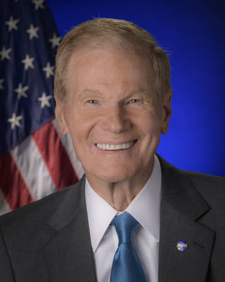
Sen. Bill Nelson has a rich background qualification that traces back for decades, having being president of 4-H before taking up the presidency for the Key Club in high school. His community service extended to his college years, where he was involved in various service organizations while at the University of Florida, Yale. His service at the national level began in his as Captain of the U.S Army, serving in active duty, and extended into public service for more than four decades. Having been elected three times into the U.S. Senate to represent Florida, Sen. Bill continued his service in the state legislature, Congress, and State Treasurer's capacity (Dunbar, 2021).
In his professional tenure, Sen. Nelson has held influential positions, including chairing the U.S. House of Representatives Space Subcommittee, a position that he maintained for six years before going ahead to serving as a ranking member in the Senate Commerce, Science, and Transportation Committee (Dunbar, 2021). Throughout his professional undertakings, Sen. Nelson has always stood out as a major advocate for NASA's programs, being an active member in vocalizing and even authoring legislation that aims to improve the agency's future. For instance, Sen. Nelson co-authored the landmark NASA legislation, which has been credited for mapping out the agency's future and setting it onto its current course. In addition, in 2017, the Senator was part of the team responsible for authoring the NASA Transition Authorization Act of 2017, expanding the agency's commercial operations in space (Dunbar, 2021). In a nutshell, his contributions have placed him among the main qualified individuals for his current position as the agency's administrator.
His commitment to NASA's programs and space exploration is already bearing fruit evidence of pivotal space travel and exploration catching the airwaves. For instance, in an interview with Washington Post columnist David Ignatius, the Senator expresses his belief in the existence of advanced technologies that will facilitate human transportation and survival on Mars for up to six months (Ignatius, 2021). He has also been at the forefront in promoting NASA's partnership with private sector players to propel the launch of human spaceflights from the U.S. in the near future. Under the Biden administration, there has been a keen development in private-public partnerships that aims to commercialize space travel and improve the universe and space exploration, and Sen. Nelson has been at the forefront in propelling this mission. Therefore, based on the government's priority in space exploration, Sen. Nelson presents as the most appropriate individual to facilitate the achievement of the specific goals.

References
BritannicaEditors (2020, January 28). National Aeronautics and Space Administration. Encyclopedia Britannica. https://www.britannica.com/topic/NASA
Dunbar, B. (Ed). 2021. NASA Administrator Bill Nelson. National Aeronautics and Space Administration (NASA). https://www.nasa.gov/feature/nasa-administrator-bill-nelson/
Ignatius, D. (2021).The Path Forward: New Frontiers in Space with NASA Administrator Bill Nelson. The Washington Post. https://www.washingtonpost.com/washington-post-live/2021/07/21/path-forward-new-frontiers-space-with-nasa-administrator-bill-nelson/

